Electric Vehicle Powertrain Modeling, Control and CAN Communication Simulation
Platform: MATLAB/Simulink
Subsystems: Vehicle Dynamics, Battery Model, CAN Communication, PID Speed Controller
Method: State-Space Dynamic Modeling and CAN-Based System Integration

1. Introduction and Objectives
This project aims to develop and simulate a complete Electric Vehicle (EV) powertrain model integrating vehicle longitudinal dynamics, battery management, and CAN Bus communication in MATLAB/Simulink. The models allow for real-time communication between subsystems with CAN protocol and analyzes the effect of road grade (0°, 5°, 10°) on battery SOC, terminal voltage, and current behavior.
The main objectives were:
- To model longitudinal vehicle dynamics using a state-space approach.
- To implement a PID-based speed control system that generates torque demand.
- To integrate Battery Model and Vehicle Model via CAN communication.
- To evaluate system performance under varying road slopes.

2. Vehicle Dynamics Modeling

2.1 Mathematical Representation
The longitudinal Dynamics of the vehicle are derived from Newton’s secand law:
$$m.\dot{v}=\frac{T_{m}{​η}_{g}}{r_{t}}-(F_{aero}+F_{roll}+F_{grade})$$
where:
$$F_{aero}=\frac{1}{2}ρC_{d}Av^{2}$$
$$F_{roll}=mgC_{rr}\cos{θ}$$
$$F_{grade}=mg\sin{θ}$$

The state-space form becomes:
$$\dot{x}\left(t\right)=Ax\left(t\right)+Bu\left(t\right)$$
$$y\left(t\right)=Cx\left(t\right)+Du(t)$$
with
$x\left(t\right)=v\left(t\right), u\left(t\right)=T_{m}$
$$A= \left[-\frac{ρC_{d}A}{m}\right], B=\left[\frac{η_{g}}{mr_{t}}\right], C=\left[1\right], D= \left[0\right]$$
The physical model is:
$$F_{net}=F_{drive}-F_{aero}-F_{roll}-F_{grade}$$
$$a_{vehicle}=\frac{F_{net}}{m}$$
$$v= \int{a_{vehicle}}dt$$

To explain why this structure are chosen:
Reason | Explanation
Modularity | Each physical effect (engine, air drag, road, rolling resistance) is represented by a separate block, allowing easy future integration of ECU, CAN, or PID features.
Realistic Physics | The force–acceleration–velocity flow strictly follows classical Newtonian mechanics.
Control Compatibility | A closed-loop control can be added via the wheel_Torque_Nm input using a PID controller.
Simulink Compatibility | All blocks are built from basic Simulink libraries and can run without any additional Toolboxes.

2.2 Mathematical Parameters

Parameter | Symbol | Value | Unit | Description
Vehicle Mass | m | 1200 | kg | Includes driver and payload
Air Density | ρ | 1.225 | kg/m³ | Standard air at 25°C
Drag Coefficient | Cd | 0.32 | - | Medium-size passenger vehicle
Frontal Area | A | 2.2 | m² | Projected area
Tire Radius | rt | 0.3 | m | Equivalent wheel radius
Rolling Resistance | Crr | 0.015 | - | Asphalt road condition
Gear Efficiency | ηg | 0.9 | - | Mechanical drivetrain loss factor

2.3 Vehicle Implementation
- Implemented using Gain and Integrator blocks for state-space realization(Fig. 2.3.1).
- The signals are transmitted with CAN Pack to other subsystems.
- The subsystem uses Sum and product blocks to compute resistive forces dynamically.
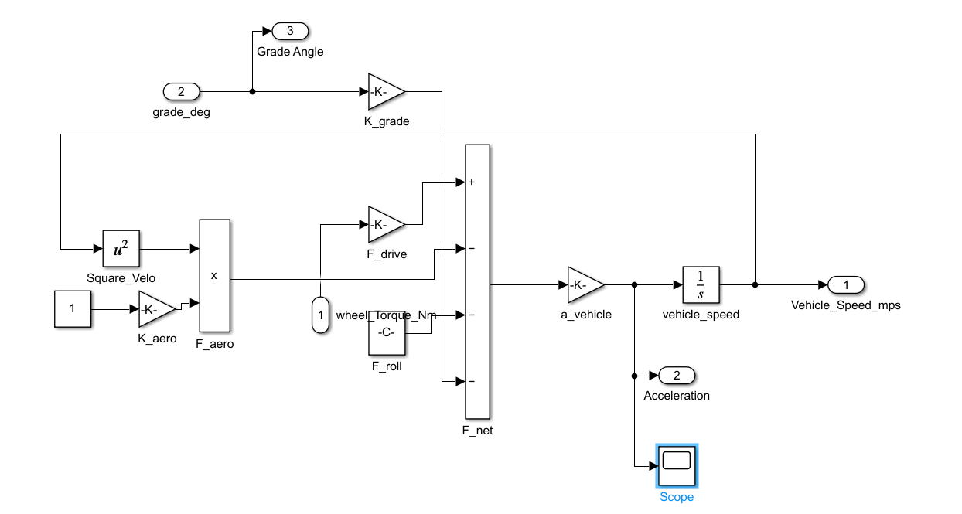

Figure 2.3.1: Vehicle dynamic Subsystem

3. Battery Model Subsystem
3.1 Dynamic Equations
Mechanical power and battery power were obtained in the Battery Model Subsystem by using the speed obtained from the Vehicle Dynamic Subsystem.
The Battery Model computes voltage and SOC based on internal resistance and coulomb-counting:
$$V_{term}=V_{oc}-I_{b}.R_{int}$$
$$\frac{d(SOC)}{dt}=- \frac{I_{b}}{Q_{cap}}$$
State-space form:
$$A=\left[0\right], B=\left[\frac{-1}{Q_{cap}}\right], C=\left[1\right], D=\left[0\right]$$
3.2 Parameters
Parameter | Symbol | Value | Unit | Description
Open Circuit Voltage | $$V_{oc}$$ | 360 | V | Nominal voltage
Internal Resistance | $$R_{int}$$ | 0.5 | Ω | Cell-level combined
Capacity | $$Q_{cap}$$ | 180 | Ah | Nominal battery capacity
Initial SOC | SOC | 100 | % | Fully charged condition

3.3 Subsystem Structure
- Uses Integrator to update SOC continuously.
- Gain block implements -1/$Q_{cap}$ to scale current into SOC change.
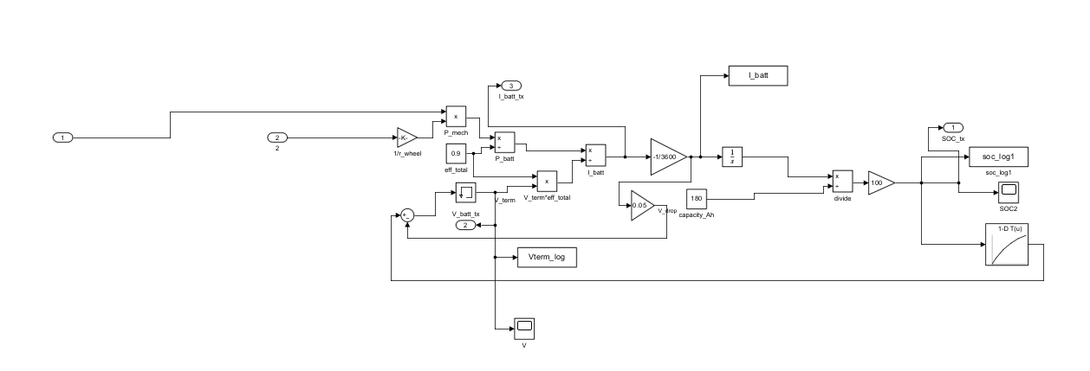
- block combines $V_{oc}$ and $I_{b}$*$R_{int}$ to obtain terminal voltagBattery Model Subsystem are shown below(Fig. 3.3.1)
Figure 3.3.1: Battery Model Subsystem
4. PID Speed Control
4.1 Control Objective
The PID controller regulates motor torque to maintain desired vehicle speed.
The error is computed as:
$$e\left(t\right)=v_{ref}-v_{vehicle}$$
and the control law is:
$$T_{m}=K_{p}e\left(t\right)+K_{i}\int{e(t)}dt+K_{d}\frac{de(t)}{dt}$$

4.2 Tuning Method
The controller was tuned using the Ziegler–Nichols step response method.
Gain | Symbol | Value
Proportional | $$K_{p}$$ | 5.6
Integral | $$K_{i}$$ | 1
Derivative | $$K_{d}$$ | 0.3

This tuning provided smooth torque response without oscillations under step speed demand.
5. CAN Bus Communication Architecture

5.1 Network Layout
Three key messages are defined:
Message ID | Name | Signal List | Size (Bytes)
100 | Battery Status | V_batt, I_batt, SOC | 6
200 | Vehicle Status | Vehicle_Speed, Acceleration, Grade_Angle | 6
300 | Torque Command | Torque_Req, Mode, Reserved | 6
Each signal uses 2 bytes (16-bit uint) encoding.

5.2 Blocks Used
- CAN Pack and CAN Unpack (Simulink/Vehicle Network Toolbox)
- Bus Creator / Bus Selector for grouping
- To Nonvirtual Bus block → prevents “virtual bus type mismatch”
- MathWorks Virtual Channel 1 as CAN interface (baud rate: 500 kbps)

5.3 Communication Flow
- Battery → Vehicle: Sends SOC, voltage, and current.
- Vehicle → Motor: Sends torque request.
- Motor → Display: Sends speed and status information.
The CAN system ensures modular communication with low computational load and reproducibility across project.
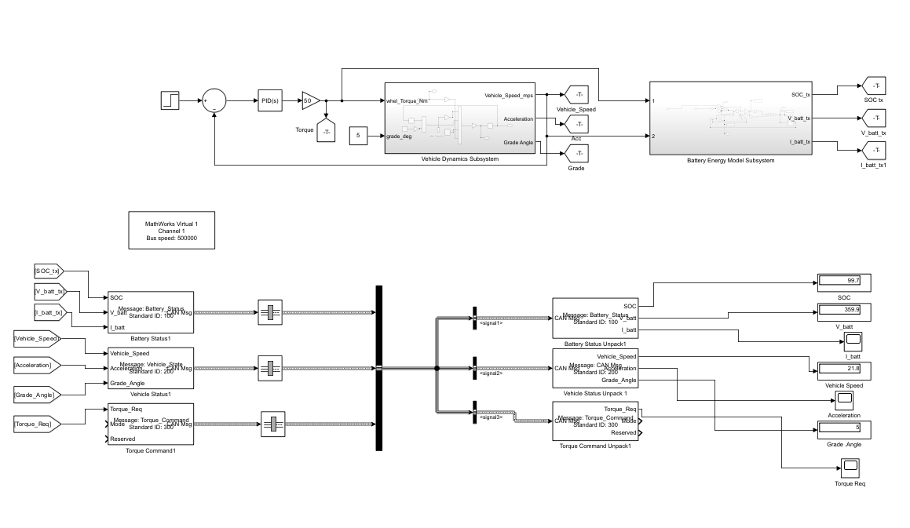
EV Powertrain Model with CAN are shown below(Fig.5.3.1):
Figure 5.3.1: EV Powertrain Model with CAN
6. Simulation Results
6.1 SOC vs Grade
- SOC decreases proportionally with increasing slope due to higher torque demand.
- The trend validates proper power coupling between vehicle dynamics and battery load.
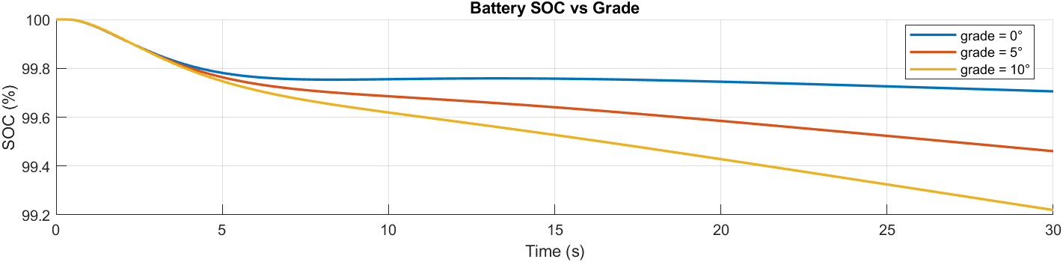
The SOC vs Grade graph are given below(Graph 6.1.1):
Graph 6.1.1: Battery SOC vs Grade

6.2 Battery Terminal Voltage
- Voltage remains nearly constant due to the high capacity of the battery and low internal resistance.
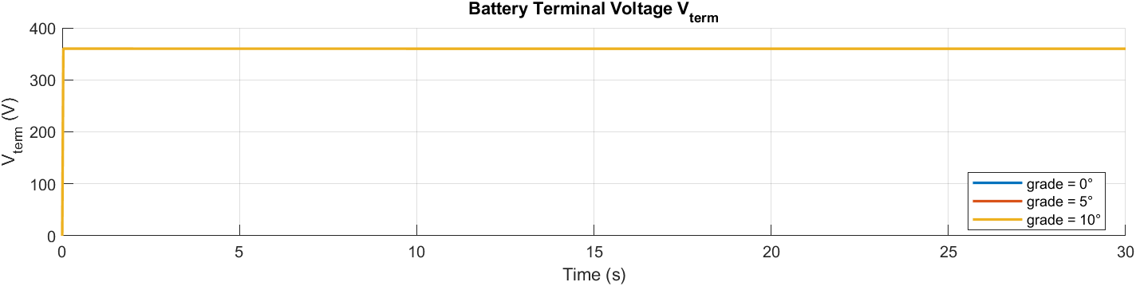
The Battery Terminal Voltage graph are given below(Graph 6.2.1):
Graph 6.2.1: Battery Terminal Voltage $V_{term}$

6.3 Battery Current
- As grade increases, current magnitude increases significantly (Fig. 3).
- The steady-state current for 10° is roughly 2.5× that of 0°.
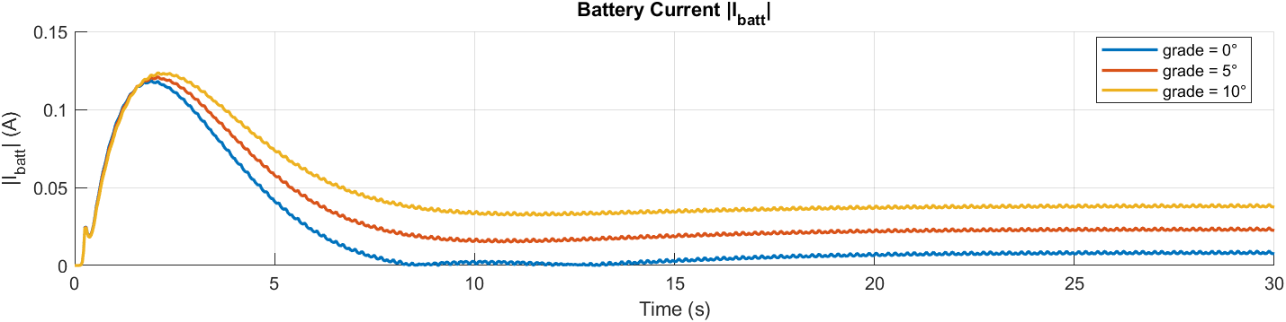
The Battery Current graph are given below(Graph6.3.1):
Graph 6.3.1: Battery Current
6.4 MATLAB Output Summary
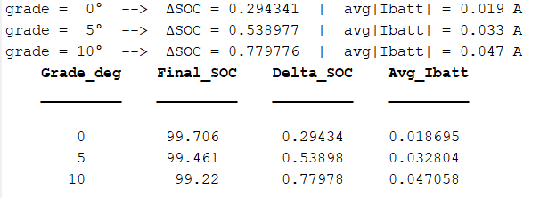
Figure 6.4.1: MATLAB Output Summary

7. Discussion
7.1 System Behavior
- The results confirm the state-space vehicle model accurately captures energy demand with grade variation.
- The PID controller ensures torque stability and smooth response.
- CAN communication allows subsystem decoupling and reliable signal flow.

7.2 Common Issues and Fixes
Issue | Cause | Solution
CAN signal not updating | Virtual bus type mismatch | Used To Nonvirtual Bus before CAN Pack
Incorrect byte allocation | Signal data types inconsistent | Converted all signals to uint16
Negative SOC value | Integration overflow | Limited SOC between 0–100%

8. Conclusion
This study demonstrates the successful design of an Electric Vehicle Powertrain model with:
- Dynamic vehicle and battery behavior using state-space modeling,
- Robust PID control for speed regulation,
- Realistic CAN Bus communication between subsystems.
The system correctly predicts the relationship between grade angle and battery energy consumption, validating the simulation framework.

References
[1] C. C. Chan, "The state of the art of electric, hybrid, and fuel cell vehicles," Proc. IEEE, vol. 90, no. 2, pp. 247–275, Feb. 2002.
[2] M. Ehsani, Y. Gao, and A. Emadi, Modern Electric, Hybrid Electric, and Fuel Cell Vehicles: Fundamentals, Theory, and Design, 2nd ed. Boca Raton, FL, USA: CRC Press, 2009.
[3] H. He, R. Xiong, and H. Guo, "Online estimation of model parameters and state-of-charge of lithium-ion batteries in electric vehicles," Appl. Energy, vol. 89, no. 1, pp. 413–420, Feb. 2012.
[4] G. L. Plett, "Extended Kalman filtering for battery management systems of LiPB-based HEV battery packs, Part 1: Background," J. Power Sources, vol. 134, no. 2, pp. 252–261, Aug. 2004.
[5] R. Rajamani, Vehicle Dynamics and Control, 2nd ed. New York, NY, USA: Springer, 2012.
[6] MathWorks, "Vehicle Dynamics Blockset: Longitudinal Vehicle Model," MathWorks Documentation, 2024. [Online]. Available: https://www.mathworks.com/help/vdynblks/longitudinal-vehicle-model.html. [Accessed: 6-Nov-2025].
[7] MathWorks, "Powertrain Blockset: Electric Vehicle Reference Application," MathWorks Documentation, 2024. [Online]. Available: https://www.mathworks.com/help/autoblks/ev-reference-application.html. [Accessed: 6-Nov-2025].
[8] MathWorks, "Vehicle Network Toolbox: CAN Communication Interface," MathWorks Documentation, 2024. [Online]. Available: https://www.mathworks.com/help/vnt/ug/can-interface.html. [Accessed: 6-Nov-2025].
[9] MathWorks, "Simulink Control Design: PID Tuning Methods," MathWorks Documentation, 2024. [Online]. Available: https://www.mathworks.com/help/slcontrol/ug/pid-tuning-methods.html. [Accessed: 6-Nov-2025].
[10] International Organization for Standardization, ISO 11898-1:2015 – Road Vehicles – Controller Area Network (CAN) – Part 1: Data Link Layer and Physical Signaling. Geneva, Switzerland: ISO, 2015.

Appendix A – MATLAB Code for Vehicle Dynamics Model
clc; clear; close all;

model = 'EV_Powertrain';
load_system(model);
grades = [0 5 10]; % derece
simTime = 30; % s
colors = lines(numel(grades));
% Sonuç depoları
SOCs = cell(size(grades));
Vterms = cell(size(grades));
Ibatt = cell(size(grades));
labels = strings(size(grades));
% yardımcı fonksiyon tanımı daha aşağıda olacak!
for k = 1:numel(grades)
grade_deg = grades(k);
assignin('base','grade_deg',grade_deg);
simOut = sim(model,'StopTime',num2str(simTime), ...
'SrcWorkspace','base','SaveOutput','on');
SOC = getSig(simOut,'soc_log1');
Vt = getSig(simOut,'Vterm_log');
Ib = getSig(simOut,'I_batt');

if ~isempty(SOC) && size(SOC,2) > 1, SOC = SOC(:,2); end
if ~isempty(Vt) && size(Vt,2) > 1, Vt = Vt(:,2); end
if ~isempty(Ib) && size(Ib,2) > 1, Ib = Ib(:,2); end
SOCs{k} = SOC;
Vterms{k} = Vt;
Ibatt{k} = Ib;
labels(k) = sprintf('grade = %d°',grade_deg);
dSOC = SOC(1) - SOC(end);
fprintf('grade = %2d° --> ΔSOC = %.6f | avg|Ibatt| = %.3f A\n', ...
grade_deg, dSOC, mean(abs(Ib)));
end
t = linspace(0,simTime,numel(SOCs{1})); % örnekleme eşitse iş görür
figure('Name','Karşılaştırma','Color','w','Position',[100 100 1100 800]);
subplot(3,1,1); hold on; grid on; title('Battery SOC vs Grade'); xlabel('Time (s)'); ylabel('SOC (%)');
for k=1:numel(grades), plot(t,SOCs{k},'LineWidth',1.6,'Color',colors(k,:)); end
legend(labels,'Location','best');
subplot(3,1,2); hold on; grid on; title('Battery Terminal Voltage V_{term}'); xlabel('Time (s)'); ylabel('V_{term} (V)');
for k=1:numel(grades), plot(t,Vterms{k},'LineWidth',1.6,'Color',colors(k,:)); end
legend(labels,'Location','best');
subplot(3,1,3); hold on; grid on; title('Battery Current |I_{batt}|'); xlabel('Time
(s)'); ylabel('|I_{batt}| (A)');
for k=1:numel(grades), plot(t,abs(Ibatt{k}),'LineWidth',1.6,'Color',colors(k,:)); end
legend(labels,'Location','best');
% (Opsiyonel) tablo
final_SOC = cellfun(@(x) x(end), SOCs);
delta_SOC = cellfun(@(x) x(1)-x(end), SOCs);
avg_Ibatt = cellfun(@(x) mean(abs(x)), Ibatt);
disp(table(grades',final_SOC',delta_SOC',avg_Ibatt', ...
'VariableNames',{'Grade_deg','Final_SOC','Delta_SOC','Avg_Ibatt'}))
function sig = getSig(simOut,name)
try
sig = simOut.get(name);
catch
try
sig = simOut.find('Name',name).Values.Data;
catch
sig = [];
end
end
end

